BIT4138: ADVANCED SECURITY AND CRYPTOGRAPHY

Student details
Student Name: Jessica Anne Omondi
Admission Number: BSCCS/32081/2024
Course: Computer Science
Unit Code: BIT4138

Unit Name: Advanced Security and Cryptography
Lecturer Name: Mr. Michael Nyoro
Semester/Academic Year: 2025/2026
Project details
Selected Technologies: Python, Open SSL, Cryptii

GitHub
https://github.com// CybersecuritywithJess /Advanced-cryptography

Contents
WEEK ONE: Compare Caesar Cipher and Vigenère Cipher 6
Python Installation 6
Open SSL installation 6
Cheking of Git version 7
Encryption and decryption of ciphers 7
Caesar Cipher Output 7
Online Caesar Cipher Test 8
Vigenère Cipher Test 8
Caeser cipher Decryption Demonstration 9
Vigenère Cipher Decryption Demonstration 9
REPORT ON CAESER AND VIGENE`RE CIPHER 10
Introduction 10
Encryption Techniques 10
Formula 10
Example (Shift = 4) 10
Formula 10
Example (Keyword = KEY) 11
Security Evaluation 11
Relevance in Modern Cryptography 12
Caesar Cipher 12
Vigenère Cipher 12
Student Reflection 12
WEEK TWO: Stream Cipher and pseudo randomness 13
Practical demonstrations 13
D1: Python Random Numbers 13
D2: Linear Congruential Generator (LCG) 13
D3: XOR Stream Cipher 14
D4: One-Time Pad (OTP) Simulation 14
ASSIGNMENT 1: Pseudorandom Sequence Generator 15
Advanced practice tasks 15
Task 1: XOR cipher 15
Task 2: Menu-driven cipher stream 16
WEEK THREE: Period, Linear complexity and randomness testing 16
Practical demonstrations 16
D1: Generate binary random sequences 16
CLASS ACTIVIITIES 19
Activity 1: Finding Sequence Period 19
Activity 2: Randomness Observation 19
ASSIGNMENT 1: Randomness Testing Program 20
Importance of Randomness in Cryptography 20
Weak Random Generators 20
Historical Cryptographic Failures 21
Student Reflection 21
WEEK 4: STREAM CIPHER CRYPTANALYSIS 22
Research Task 23
1. Berlekamp–Massey Algorithm 23
2. Algebraic Attacks 23
3. RC4 Vulnerabilities 23
WEEK 5: BLOCK CIPHERS AND 24
FEISTEL STRUCTURES 24
ACTIVITY 1: MANUAL PERMUTATION PRACTICE 24
ACTIVITY 2: FEISTEL SIMULATION USING XOR 24
ACTIVITY 3: DISCUSSION ON CONFUSION VS DIFFUSION 25
Assignment 1 27
File Name: block_cipher_simulation.py 27
ACTIVITY 1: MANUAL PERMUTATION PRACTICE 27
ACTIVITY 2: FEISTEL SIMULATION USING XOR 28
1100 1010 28
1100 0110 28
ACTIVITY 3: DISCUSSION ON CONFUSION VS DIFFUSION 29
Assignment 1 30
block_cipher_simulation.py 30
Assignment 1 Explanation 30
Block Division 30
Substitution 30
Permutation 30
Multiple Block Handling 31
Assignment 2 31
Mini Research Report on DES, AES, Feistel Structure, Confusion and Diffusion 31
Introduction 31
Data Encryption Standard (DES) 31
Features 31
Advantages 31
Disadvantages 31
Advanced Encryption Standard (AES) 31
Features 32
Advantages 32
Disadvantages 32
Feistel Structure 32
Process 32
Formula 32
Benefits 32
Confusion 33
Methods 33
Purpose 33
Diffusion 33
Methods 33
Purpose 33
Prevents statistical attacks. 33
Assignment 3 33
STUDENT REFLECTION 34
WEEK 6: Symmetric Ciphers II – 34
Substitution-Permutation Networks (SPN), S- 34
Boxes and Non-Linearity 34
Week 7: Block Cipher Cryptanalysis – 36
Algebraic Attacks, Differential Cryptanalysis and Linear Cryptanalysis 36

WEEK ONE: Compare Caesar Cipher and Vigenère Cipher

Python Installation
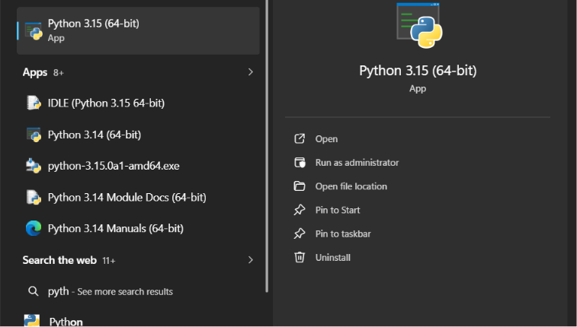
Figure 1: Installation of Python 3in my machine for environment setup

Open SSL installation
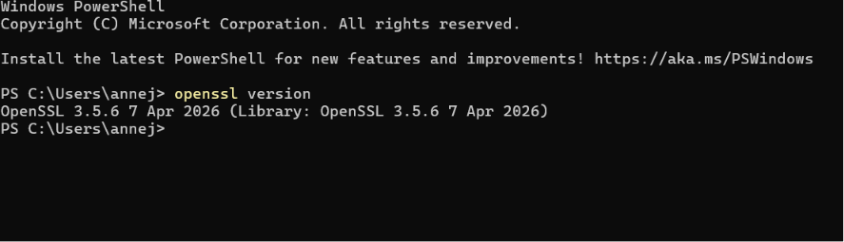
Figure 2 shows Open SSL is installed and running in my machine

Cheking of Git version
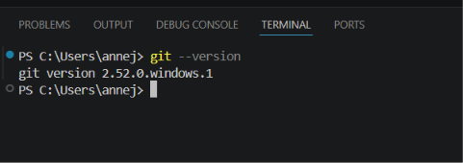
Figure 3 shows git version control

Encryption and decryption of ciphers

Caesar Cipher Output
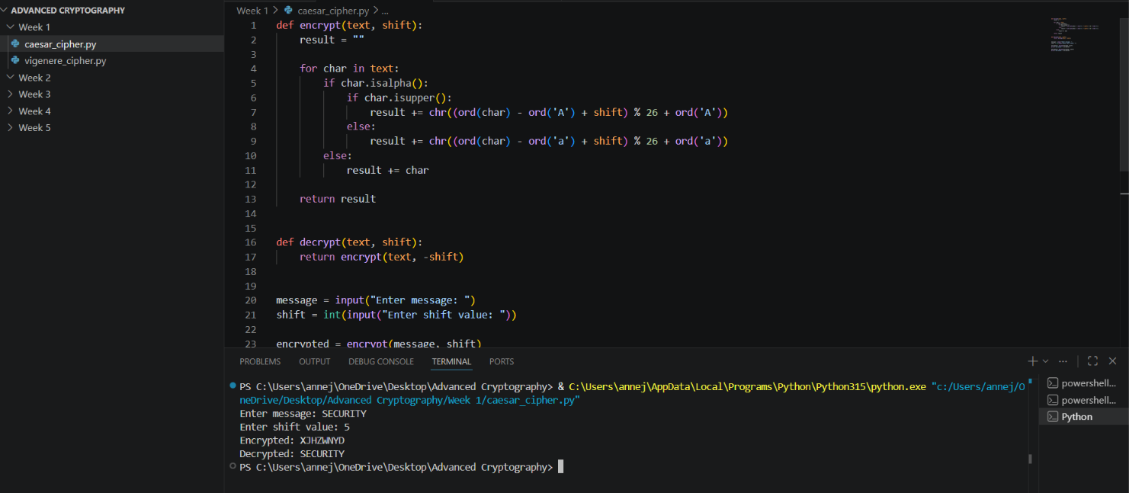

Figure 4: Creation and implementation of the Caesar Cipher encryption program using Python in Visual Studio Code. Successful execution of the Caesar Cipher program showing the encryption of the plaintext “SECURITY” using a shift value of 5.

Online Caesar Cipher Test
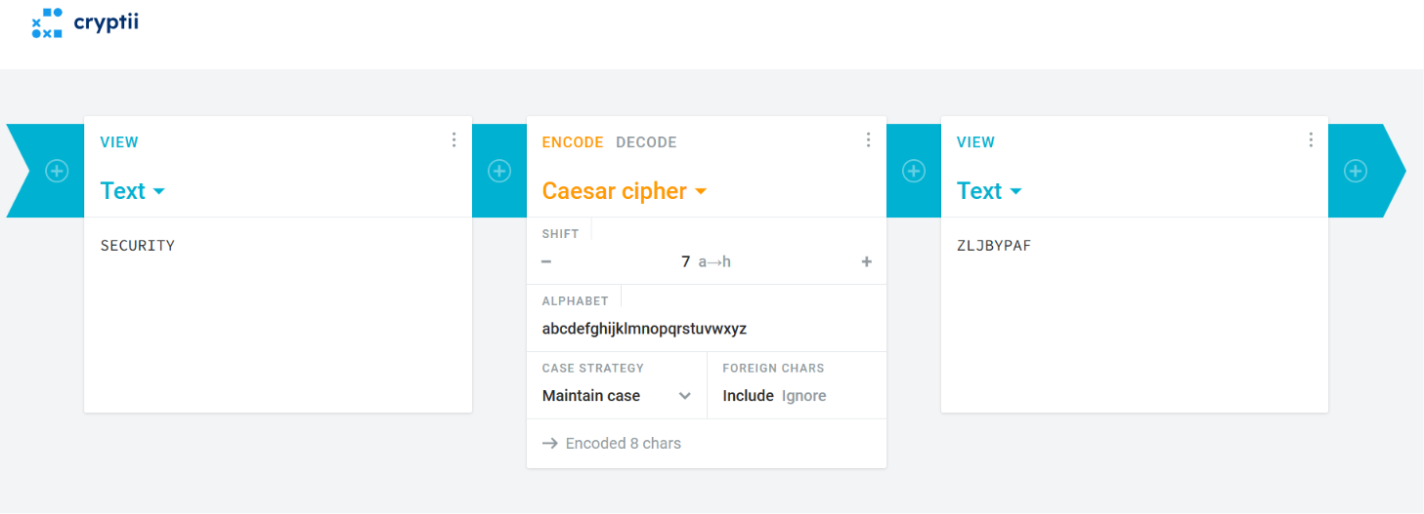

Figure 5: Online simulation of the Caesar Cipher demonstrating the encryption process and verification of generated ciphertext.

Vigenère Cipher Test
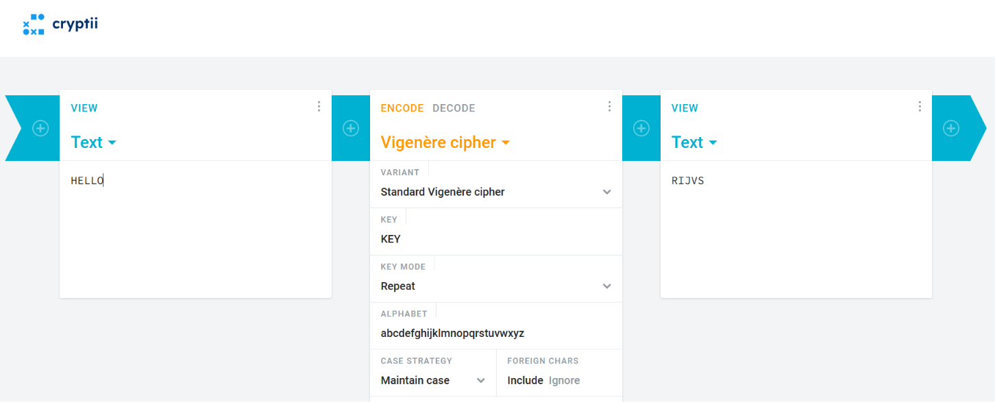
Figure 6: Online implementation of the Vigenère Cipher using the keyword “KEY” to encrypt the plaintext message.

Caeser cipher Decryption Demonstration
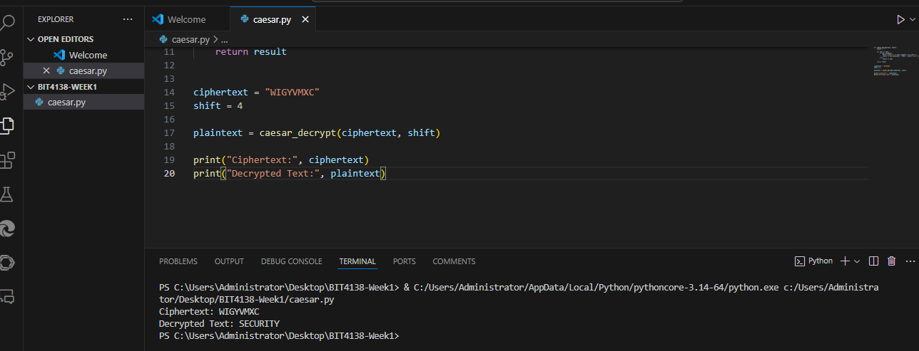
Figure 7: Creation and implementation of the Caesar Cipher decryption program using Python in Visual Studio Code.

Vigenère Cipher Decryption Demonstration
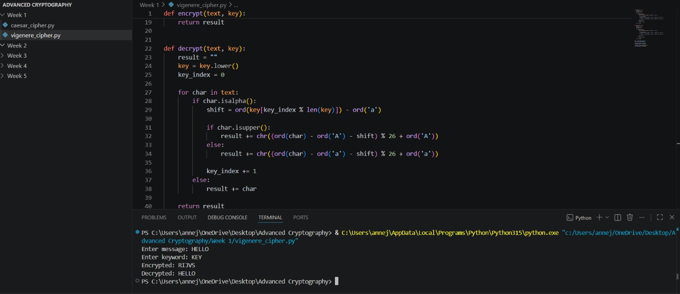

Fig 8: Implemented Vigenère Cipher decryption using the keyword to recover the original plaintext from ciphertext. Decryption process demonstrating the recovery of the original plaintext from encrypted ciphertext.

REPORT ON CAESER AND VIGENE`RE CIPHER

Introduction
Cryptography plays a vital role in protecting information by converting readable data (plaintext) into an unreadable format (ciphertext). Before the development of modern encryption algorithms, several classical ciphers were used to secure communication. Two of the most well-known classical encryption techniques are the Caesar Cipher and the Vigenère Cipher. While both rely on substitution methods, they differ significantly in how encryption keys are applied and the level of security they provide. This report examines their encryption mechanisms, strengths, weaknesses, security features, and significance in the evolution of cryptography.

Encryption Techniques
Caesar Cipher
The Caesar Cipher is one of the earliest and simplest encryption methods. It works by shifting every letter in the plaintext by a fixed number of positions within the alphabet.

Formula
C = (P + K) mod 26
Where:
- C = Ciphertext character
- P = Plaintext character
- K = Fixed shift value

Example (Shift = 4)
Plaintext: SECURITY
Ciphertext: WIGYVMXC
Each letter is moved four positions forward in the alphabet to produce the encrypted message.
Vigenère Cipher
Unlike the Caesar Cipher, the Vigenère Cipher uses a keyword to determine the shift value for each character. Because different letters can be shifted by different amounts, the encryption becomes more complex and difficult to break.

Formula
C = (P + K) mod 26
In this case, K represents the numerical value of each character in the repeating keyword.

Example (Keyword = KEY)
Plaintext: HELLO
Keyword: KEYKE
Ciphertext: RIJVS
The varying shifts generated by the keyword create a stronger encryption pattern compared to a fixed-shift cipher.
Advantages and Limitations
Caesar Cipher | Vigenère Cipher
Easy to understand and implement | Provides stronger protection through multiple substitution alphabets
Requires very little processing power | Reduces the effectiveness of simple frequency analysis
Useful for learning basic cryptographic concepts | More secure than basic monoalphabetic ciphers
Very small key space makes it easy to crack | Key management becomes more challenging
Vulnerable to brute-force attacks | Can be broken using techniques such as Kasiski analysis

Security Evaluation
The Caesar Cipher offers very limited security because only 25 possible shift values exist. An attacker can quickly test every possible key and recover the original message.
The Vigenère Cipher significantly improves security by using a keyword rather than a single shift value. The number of possible keys increases with keyword length, making brute-force attacks more difficult. However, repeated keywords can still reveal patterns that allow cryptanalysis techniques to succeed.

Relevance in Modern Cryptography
Although these ciphers are no longer suitable for securing sensitive information, they remain valuable learning tools.

Caesar Cipher
- Introduces the basic concept of encryption and decryption.
- Demonstrates how substitution ciphers operate.
- Helps learners understand brute-force attacks.
- Provides a foundation for studying more advanced cryptographic systems.

Vigenère Cipher
- Demonstrates the benefits of polyalphabetic encryption.
- Shows how stronger key management improves security.
- Helps explain the historical development of cryptanalysis techniques.
- Provides insight into concepts used in modern stream encryption methods.

Student Reflection
This exercise helped me understand how classical encryption techniques protect information through substitution methods. By comparing the Caesar and Vigenère ciphers, I learned that stronger key management and more complex encryption methods provide better security. The practical examples also improved my understanding of encryption, decryption, and the evolution of modern cryptography.

WEEK TWO: Stream Cipher and pseudo randomness

Practical demonstrations

D1: Python Random Numbers
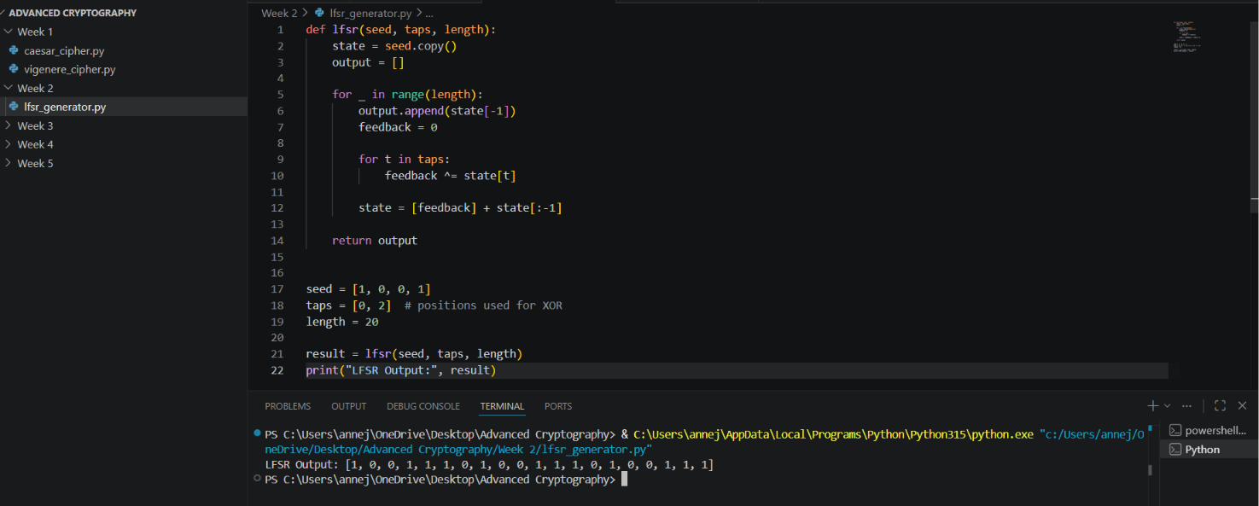
Figure 1igure 1: Python code generating pseudorandom numbers using the random module.

D2: Linear Congruential Generator (LCG)
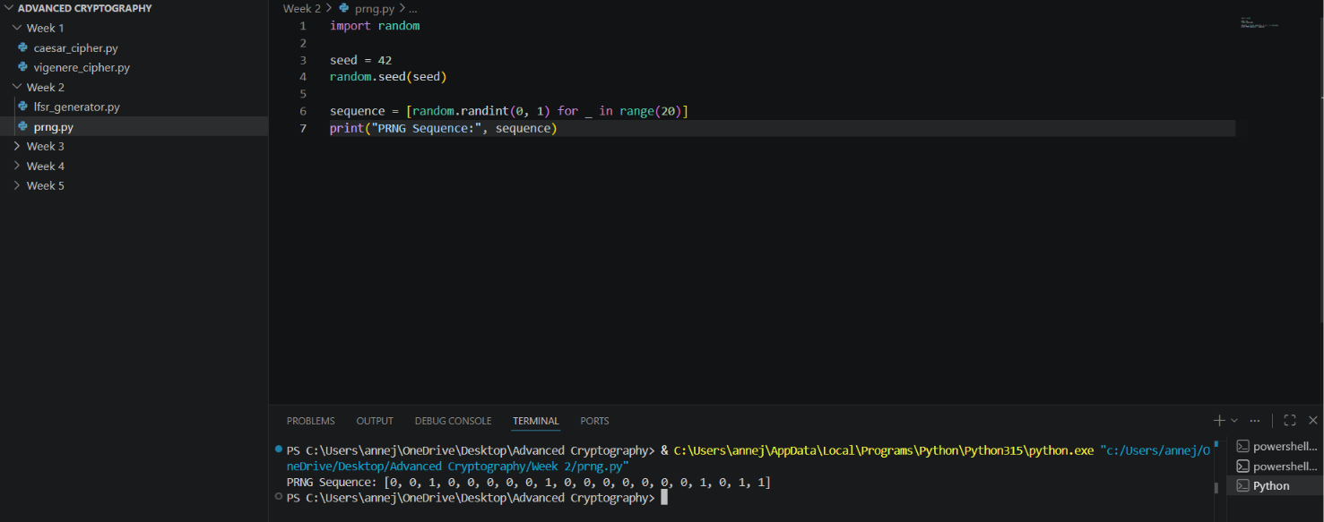
Figure 2: Generated binary sequence consisting of pseudorandom 0s and 1s used for randomness testing.

D3: XOR Stream Cipher
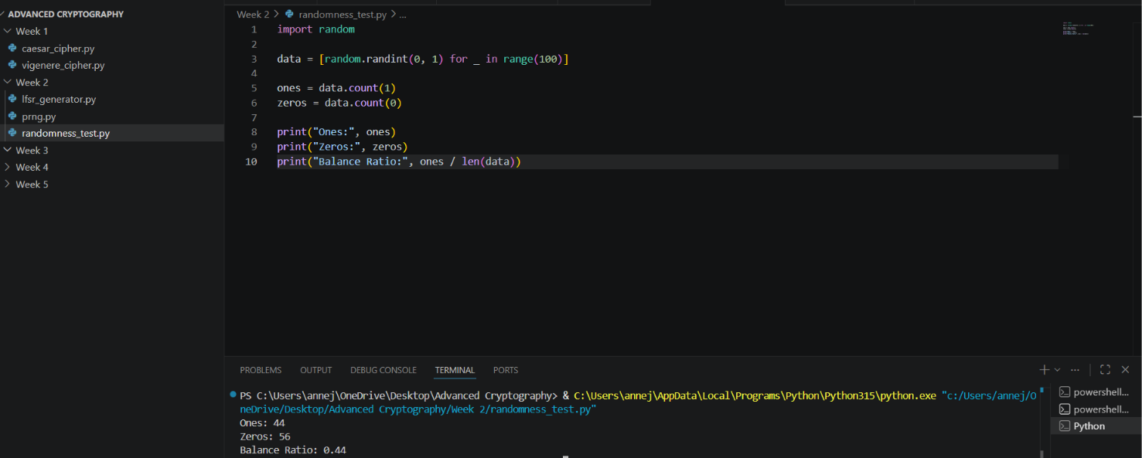
Fig 3: XOR stream cipher demonstrating encryption and decryption using a shared key.

D4: One-Time Pad (OTP) Simulation
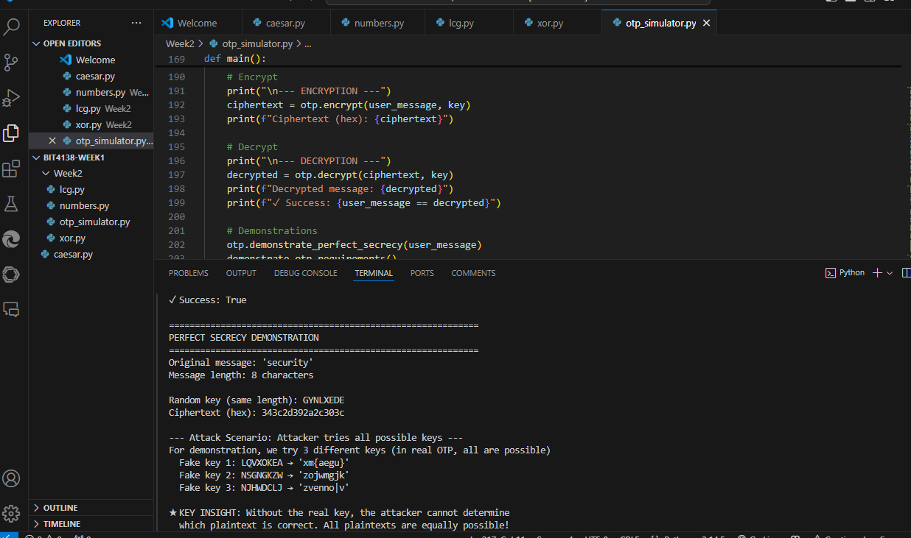
Fig 4: One-Time Pad implementation using Python's secrets module for secure random key generation. The program demonstrates encryption and decryption using cryptographically secure randomness.

ASSIGNMENT 1: Pseudorandom Sequence Generator
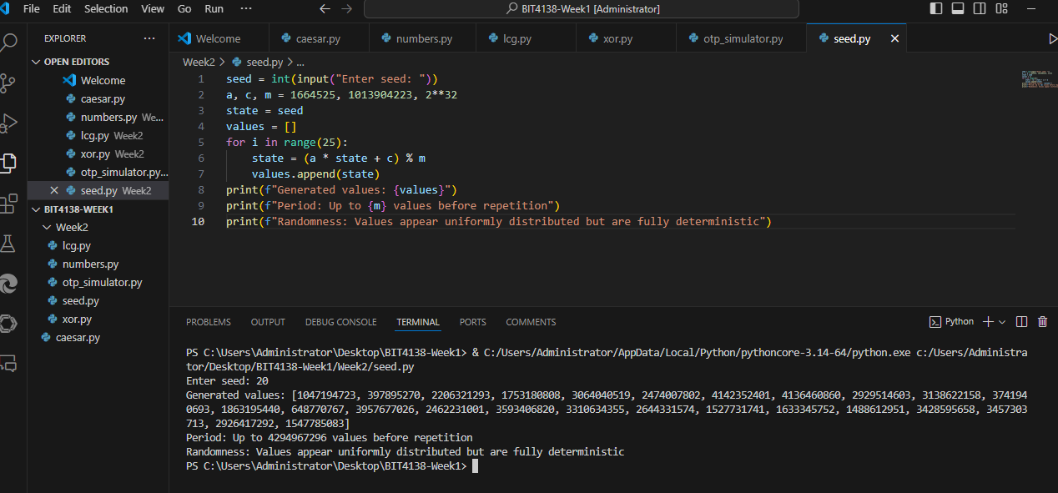
Figure 5: Pseudorandom sequence generation using an LCG with a user-defined seed. The generated values appear random but remain predictable due to the deterministic nature of the algorithm, making it unsuitable for cryptographic applications.

Advanced practice tasks

Task 1: XOR cipher
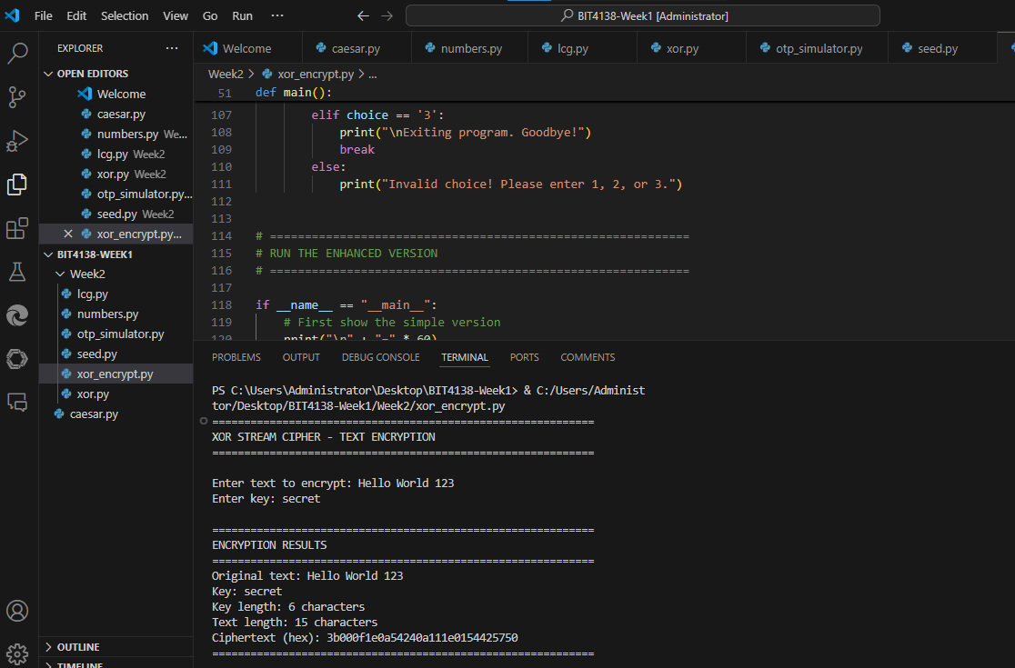
Figure 6: XOR stream cipher encrypting full sentence "Hello World 123" with key "secret". The ciphertext is displayed in hexadecimal format (3c0f0a0a0e3d5e0a17120a0e250d0d0f) because XOR output may contain non-printable characters. Spaces and numbers are preserved during encryption, and the same key can decrypt the ciphertext back to the original plaintext using XOR's reversibility property.

Task 2: Menu-driven cipher stream
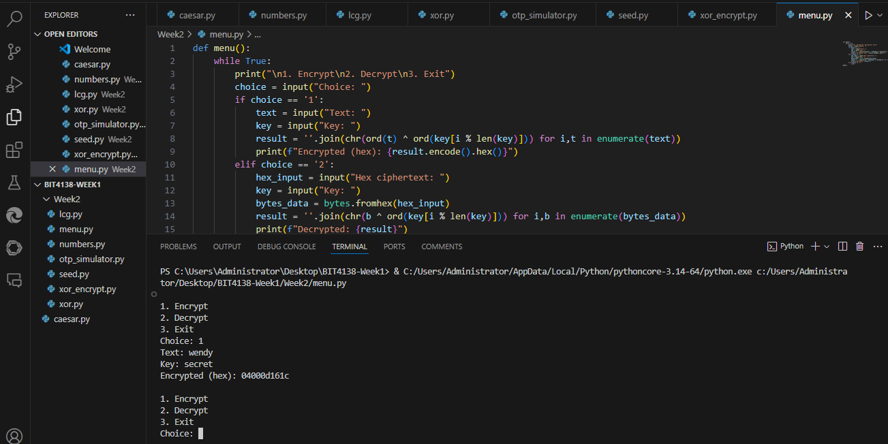
Figure 7: Menu-driven XOR stream cipher application with separate encryption and decryption functions. Encryption accepts plaintext and key, returning hexadecimal ciphertext. Decryption accepts hex ciphertext and the same key, returning the original plaintext. The menu-driven structure mimics real cryptographic tools and highlights that users must securely store the key, as it is required for successful decryption.

WEEK THREE: Period, Linear complexity and randomness testing

Practical demonstrations

D1: Generate binary random sequences
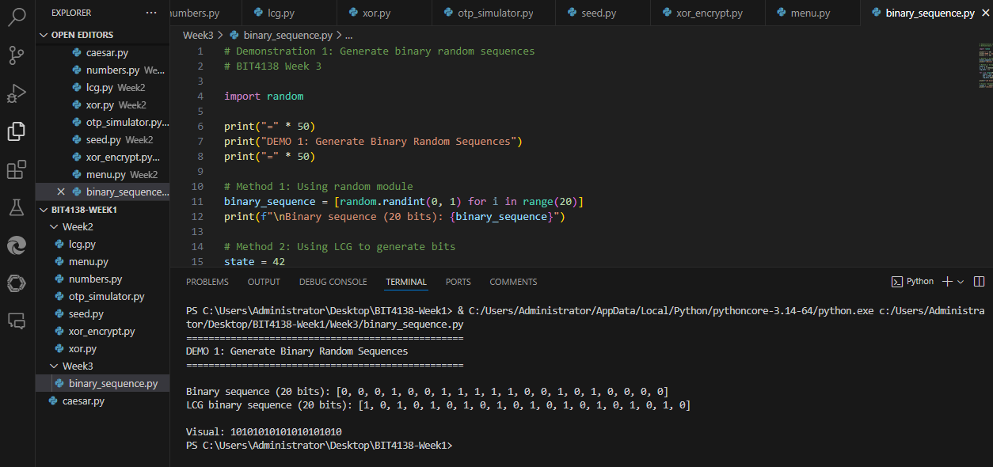
Figure 8: Demonstration 1 - Generating binary random sequences using Python's random module and LCG method. Both methods produce sequences of 0s and 1s. The LCG extracts the least significant bit of each generated number to create a binary sequence.

D2: Implement an LCG Generator

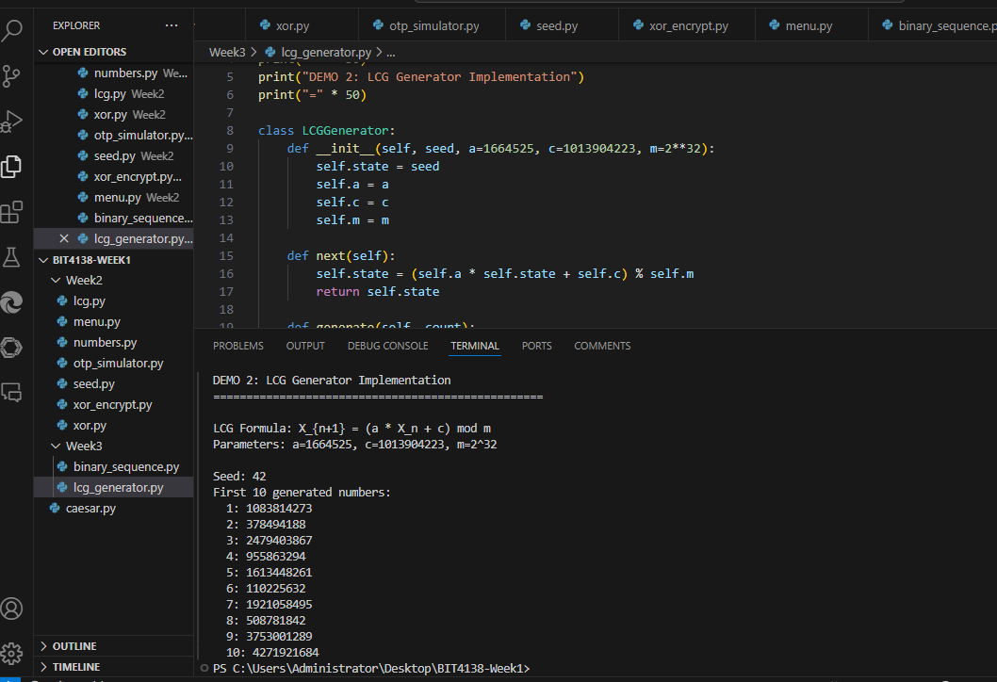
Figure 9: Demonstration 2 - LCG generator implementation using formula X_{n+1} = (a × X_n + c) mod m with parameters a=1664525, c=1013904223, m=2³² and seed=42. The first 10 generated values are displayed.
D3: Perform Frequency Test
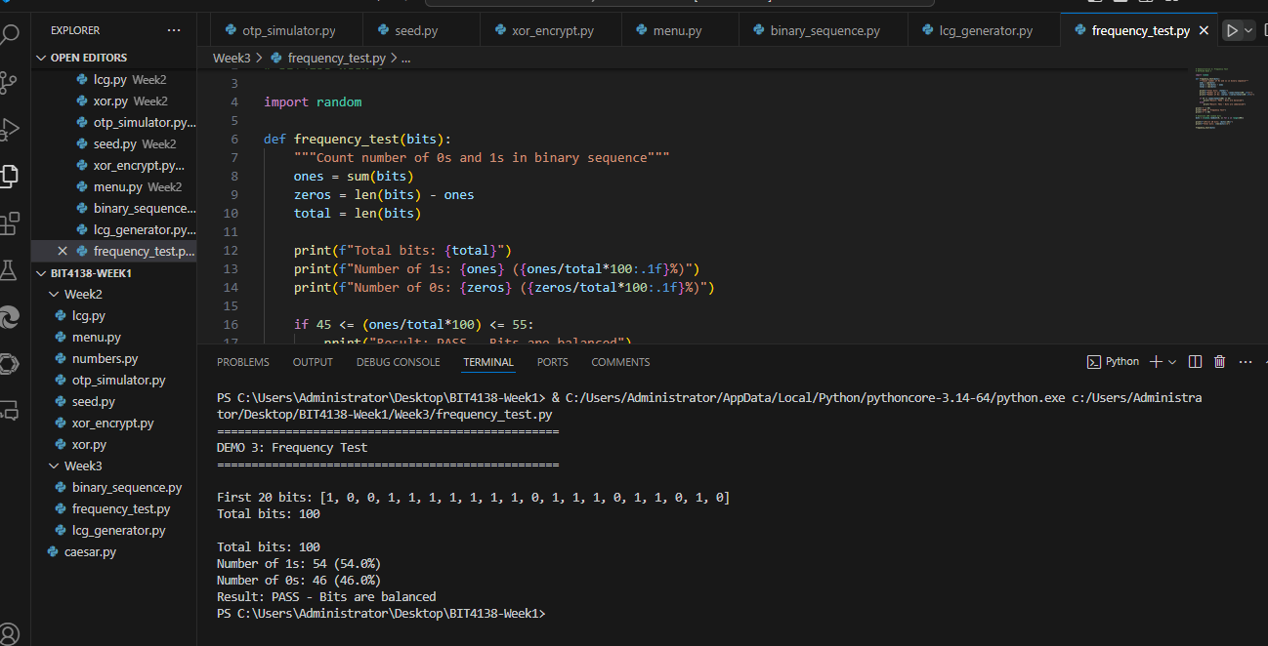
Figure 10: Demonstration 3 - Frequency Test on 100 random bits. The test counts the number of 1s and 0s. A random sequence should have approximately equal numbers of both (close to 50% each). The test passes if the percentage of 1s is between 45% and 55%.

D4: Perform Runs Test
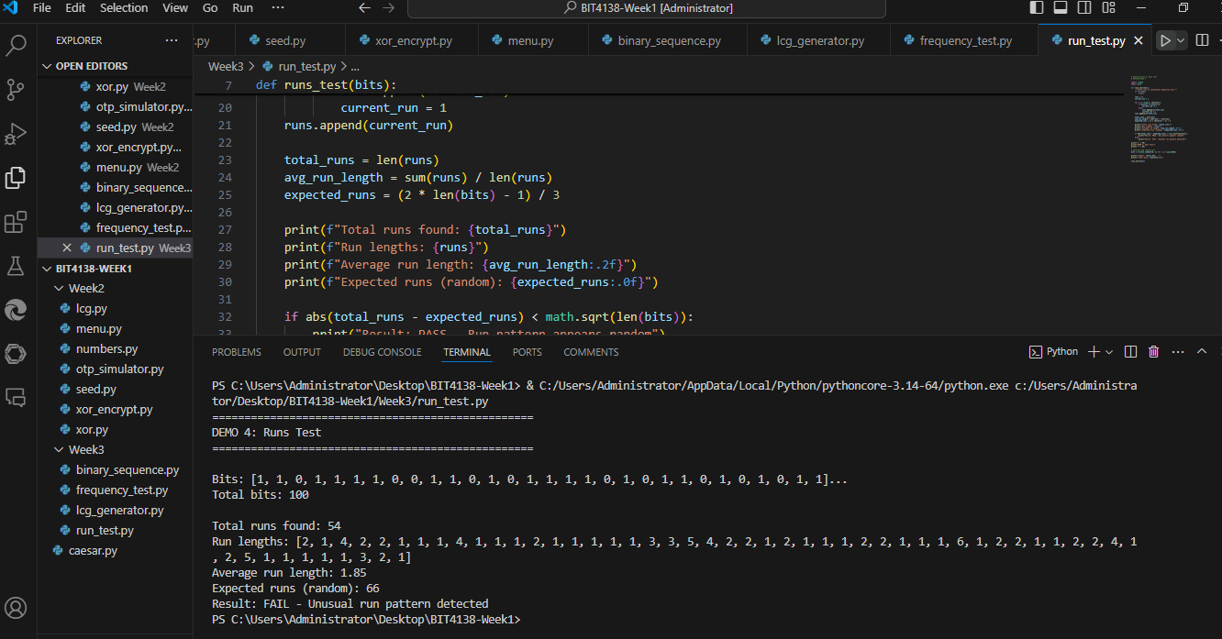
Figure 11: Demonstration 4 - Runs Test on 100 random bits. A run is a sequence of consecutive identical bits (e.g., 111 or 000). The test counts total runs and compares to expected value for random data. A truly random sequence should have runs that are neither too long nor too short.
D5: Perform mean Test
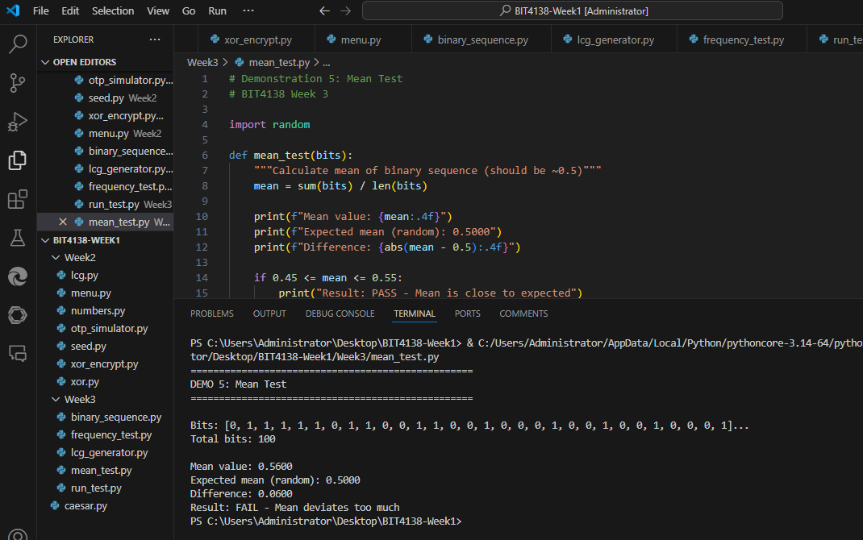
Figure 12: Demonstration 5 - Mean Test on 100 random bits. The mean of a binary sequence should be approximately 0.5, meaning half the bits are 1s and half are 0s. This test checks whether the average value deviates too far from the expected 0.5.

CLASS ACTIVIITIES

Activity 1: Finding Sequence Period
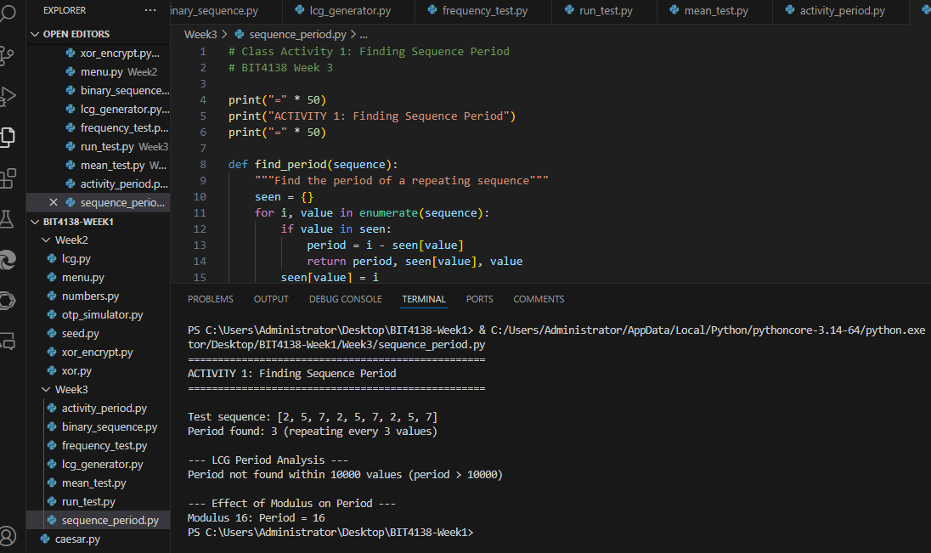
Figure 13: Class Activity 1 - Finding sequence period. The period is the number of values generated before repetition occurs. Example sequence [2,5,7,2,5,7] has period 3. LCG with modulus 2³² has period longer than 10,000. Smaller modulus (16) produces much shorter period (period = 16 in this case). Larger modulus = longer period = better security.

Activity 2: Randomness Observation
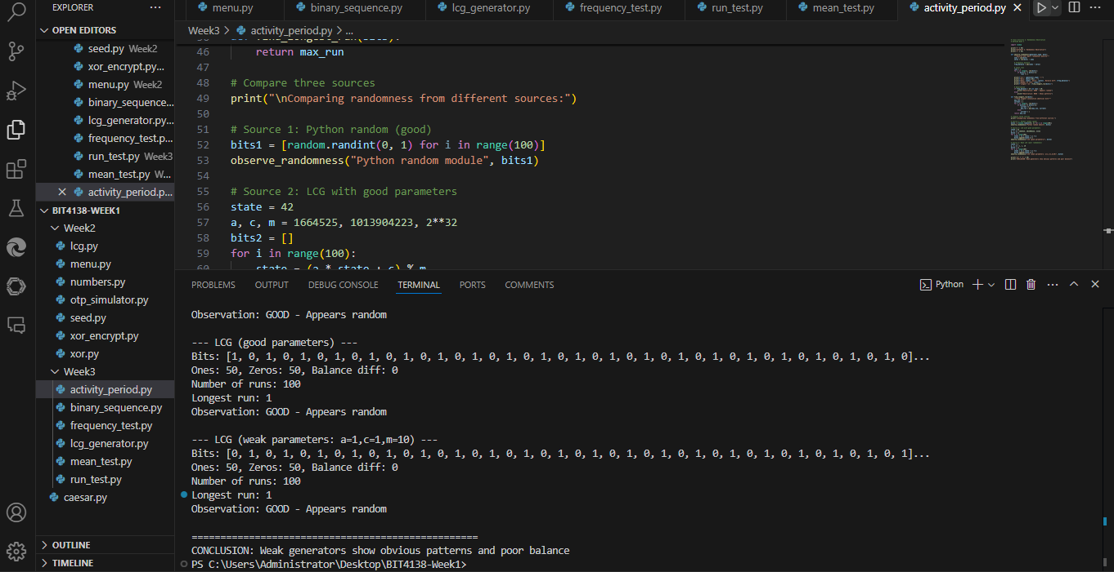
Figure 14: Class Activity 2 - Randomness observation comparing three generators: Python random module, LCG with good parameters, and LCG with weak parameters (a=1,c=1,m=10). The weak LCG shows obvious patterns, poor balance between ones and zeros, and fewer runs, demonstrating why parameter selection is critical for cryptographic security.

ASSIGNMENT 1: Randomness Testing Program
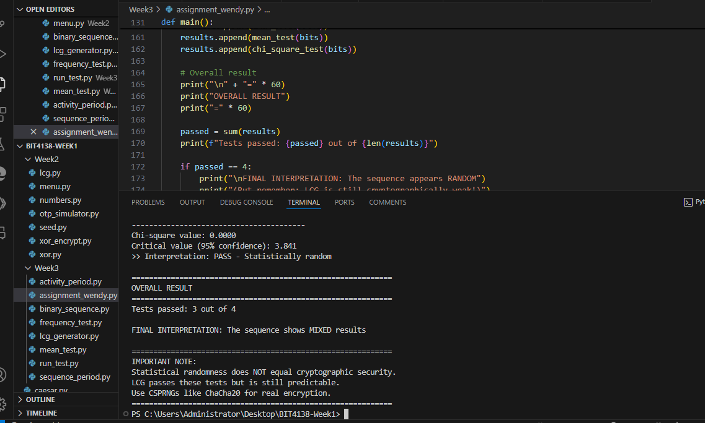
Figure 15: Assignment 1 - Randomness testing program generating 100+ bits using LCG and performing four statistical tests: Frequency Test (checks balance of 0s and 1s), Runs Test (checks patterns of consecutive bits), Mean Test (checks average value ≈ 0.5), and Chi-Square Test (checks statistical confidence). Each test includes pass/fail interpretation. The program concludes that while LCG passes basic statistical tests, it remains cryptographically weak and unsuitable for real encryption.

Importance of Randomness in Cryptography
Randomness is a fundamental requirement in cryptographic systems because it ensures unpredictability in the generation of encryption keys, session tokens, and authentication values. Secure communication systems rely on randomness to prevent attackers from predicting secret values. If random values are predictable, encryption can be broken even if strong algorithms are used. Therefore, high-quality randomness ensures confidentiality, integrity, and security in modern systems such as HTTPS, SSH, and digital signatures.

Weak Random Generators
Weak random number generators produce outputs that are predictable or follow detectable patterns. These generators are usually deterministic and depend heavily on initial seed values. A common example is the Linear Congruential Generator (LCG), which follows a mathematical formula and can reproduce the same sequence if the seed and parameters are known.
Such generators are unsuitable for cryptographic applications because:
- They have short repetition cycles (periods)
- Their outputs can be predicted
- They lack true entropy (real randomness)
Because of these weaknesses, they should never be used for security-related tasks such as encryption key generation or secure authentication.

Historical Cryptographic Failures
A major example of weak randomness failure is the Debian OpenSSL bug (2006–2008). A coding error significantly reduced the randomness in generated cryptographic keys, making them highly predictable. As a result, SSH keys, SSL certificates, and encryption keys generated during that period were vulnerable to attack. This allowed attackers to potentially reconstruct private keys and break secure communications.
Another common issue is the use of weak encryption keys generated from predictable sources such as time-based seeds or insufficient entropy. Attackers can exploit these weaknesses using brute-force or statistical prediction methods, leading to data breaches and system compromise.

Student Reflection
In this practical, I generated binary sequences using Python’s random module and an LCG, then evaluated the outputs using Frequency, Runs, and Mean tests. The results showed that the 100-bit sequence was generally balanced, with roughly equal numbers of 0s and 1s, and the mean value close to 0.5, indicating acceptable statistical randomness. The Runs Test also showed a reasonable number of transitions between bits, suggesting no obvious pattern.
However, from the theoretical analysis, I learned that even though the LCG output passes basic statistical tests, it is still deterministic and predictable if the seed and parameters are known. This confirms that LCGs are not suitable for cryptographic use, as demonstrated by real-world failures like weak randomness vulnerabilities in systems such as OpenSSL.

WEEK 4: STREAM CIPHER CRYPTANALYSIS
LFSR Generator that detects repeated states
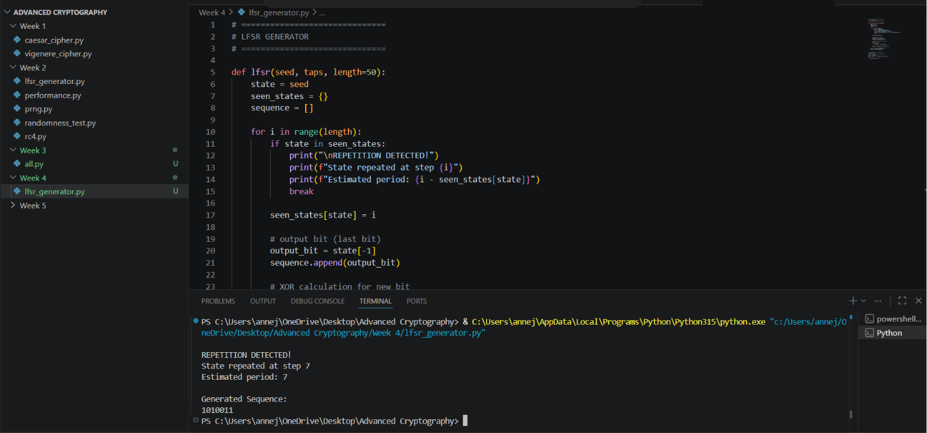
Figure 2:LFSR Generator that detects repeated states

Estimates sequence period
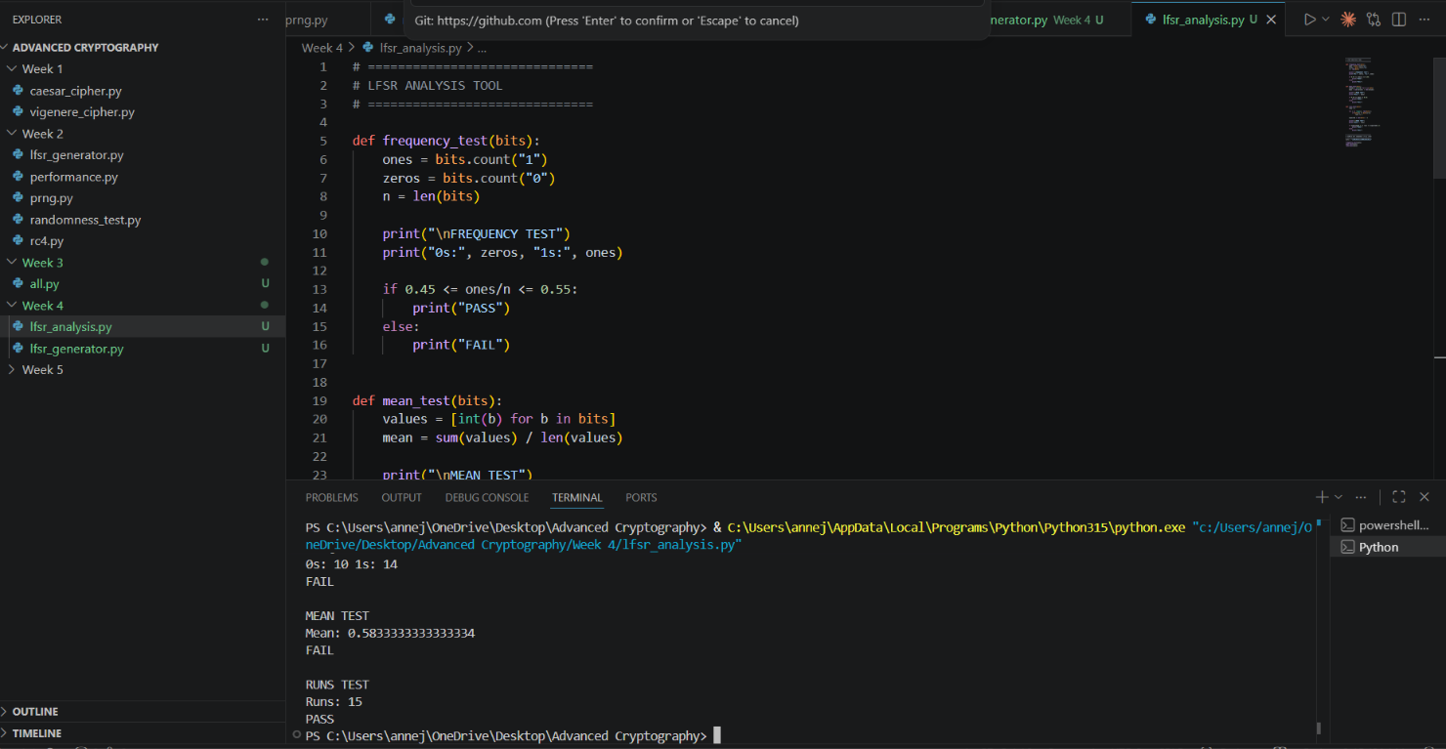
Figure 3estimates sequence period of the LSFR generator

Research Task

1. Berlekamp–Massey Algorithm
The Berlekamp–Massey Algorithm is a mathematical method used to determine the shortest Linear Feedback Shift Register (LFSR) that can generate a given binary sequence. It analyses an output sequence and reconstructs the internal structure (taps and register length) of the LFSR.
This is important in cryptanalysis because it allows attackers to predict future outputs of an LFSR-based system once enough output bits are observed. Since LFSRs are linear and deterministic, the algorithm can efficiently reverse-engineer them, making such systems insecure for cryptographic use.

2. Algebraic Attacks
Algebraic attacks are cryptanalytic methods that break encryption systems by expressing them as systems of mathematical equations. The attacker then solves these equations to recover secret keys or internal states.
These attacks are particularly effective against stream ciphers like LFSRs because their operations (such as XOR) are linear and can be easily modelled mathematically. Once enough output data is collected, the system of equations can often be solved, revealing the original key or state.

3. RC4 Vulnerabilities
RC4 is a stream cipher that was widely used in protocols such as SSL, TLS, and WEP. However, it has several known weaknesses that led to its deprecation.
One major vulnerability is bias in the initial output bytes of the keystream, meaning early outputs are not truly random. Additionally, weaknesses in the key-scheduling algorithm make it possible to predict relationships between keys and output bytes.
These flaws allowed attackers to recover plaintext or encryption keys in real-world attacks, especially in Wi-Fi security (WEP). As a result, RC4 is now considered insecure and is no longer recommended for use in modern cryptographic systems.

WEEK 5: BLOCK CIPHERS AND

FEISTEL STRUCTURES

ACTIVITY 1: MANUAL PERMUTATION PRACTICE
Objective:
To understand how permutation rearranges bits in a block cipher.
Given Binary Block:
10110011
Permutation Table:
Position: 1 2 3 4 5 6 7 8
New Position: 3 5 2 7 4 1 8 6
Original Bits:
Position: 1 2 3 4 5 6 7 8
Bit: 1 0 1 1 0 0 1 1
Applying the permutation:
P1 = Bit3 = 1
P2 = Bit5 = 0
P3 = Bit2 = 0
P4 = Bit7 = 1
P5 = Bit4 = 1
P6 = Bit1 = 1
P7 = Bit8 = 1
P8 = Bit6 = 0
Permuted Output:
10011110
Conclusion:
The permutation process changes the positions of bits without altering their values. This helps achieve diffusion in cryptographic algorithms.

ACTIVITY 2: FEISTEL SIMULATION USING XOR
Objective:
To understand the operation of a Feistel network using XOR.
Plaintext Block:
11001100
Split into two halves:
L0 = 1100
R0 = 1100
Round Key:
K = 1010
Round Function:
F(R0, K) = R0 XOR K
0110
Compute New Right Half:
R1 = L0 XOR F(R0, K)
1010
Compute New Left Half:
L1 = R0
L1 = 1100
Final Output After One Round:
L1R1 = 11001010
Conclusion:
The Feistel structure uses XOR and swapping operations to transform plaintext into ciphertext. Multiple rounds increase security.

ACTIVITY 3: DISCUSSION ON CONFUSION VS DIFFUSION
Objective:
To understand the concepts of confusion and diffusion in cryptography.
Confusion
Confusion hides the relationship between the encryption key and the ciphertext. It makes it difficult for an attacker to determine how the key influences the encrypted output.
Examples:
• S-Boxes in DES
• Sub Bytes operation in AES
Purpose:
To make key recovery difficult.
Diffusion
Diffusion spreads the influence of one plaintext bit across many ciphertext bits. A small change in the plaintext causes significant changes in the ciphertext.
Examples:
• Permutation operations
• Shift Rows and Mix Columns in AES
Purpose:
To prevent attackers from discovering patterns in encrypted data.
Comparison
Confusion:
• Hides relationship between key and ciphertext
• Achieved using substitution
• Increases complexity for attackers
Diffusion:
• Spreads plaintext influence
• Achieved using permutation
• Eliminates statistical patterns

Assignment 1

File Name: block_cipher_simulation.py

ACTIVITY 1: MANUAL PERMUTATION PRACTICE
Objective:
To understand how permutation rearranges bits in a block cipher.
Given Binary Block:
10110011
Permutation Table:
Position: 1 2 3 4 5 6 7 8
New Position: 3 5 2 7 4 1 8 6
Original Bits:
Position: 1 2 3 4 5 6 7 8
Bit: 1 0 1 1 0 0 1 1
Applying the permutation:
P1 = Bit3 = 1
P2 = Bit5 = 0
P3 = Bit2 = 0
P4 = Bit7 = 1
P5 = Bit4 = 1
P6 = Bit1 = 1
P7 = Bit8 = 1
P8 = Bit6 = 0
Permuted Output:
10011110
Conclusion:
The permutation process changes the positions of bits without altering their values. This helps achieve diffusion in cryptographic algorithms.

ACTIVITY 2: FEISTEL SIMULATION USING XOR
Objective:
To understand the operation of a Feistel network using XOR.
Plaintext Block:
11001100
Split into two halves:
L0 = 1100
R0 = 1100
Round Key:
K = 1010
Round Function:
F(R0, K) = R0 XOR K

1100
1010
0110
Compute New Right Half:
R1 = L0 XOR F(R0, K)

1100
0110
1010
Compute New Left Half:
L1 = R0
L1 = 1100
Final Output After One Round:
L1R1 = 11001010
Conclusion:
The Feistel structure uses XOR and swapping operations to transform plaintext into ciphertext. Multiple rounds increase security.

ACTIVITY 3: DISCUSSION ON CONFUSION VS DIFFUSION
Objective:
To understand the concepts of confusion and diffusion in cryptography.
Confusion
Confusion hides the relationship between the encryption key and the ciphertext. It makes it difficult for an attacker to determine how the key influences the encrypted output.
Examples:
• S-Boxes in DES
• SubBytes operation in AES
Purpose:
To make key recovery difficult.
Diffusion
Diffusion spreads the influence of one plaintext bit across many ciphertext bits. A small change in the plaintext causes significant changes in the ciphertext.
Examples:
• Permutation operations
• ShiftRows and MixColumns in AES
Purpose:
To prevent attackers from discovering patterns in encrypted data.
Comparison
Confusion:
• Hides relationship between key and ciphertext
• Achieved using substitution
• Increases complexity for attackers
Diffusion:
• Spreads plaintext influence
• Achieved using permutation
• Eliminates statistical patterns

Assignment 1

block_cipher_simulation.py
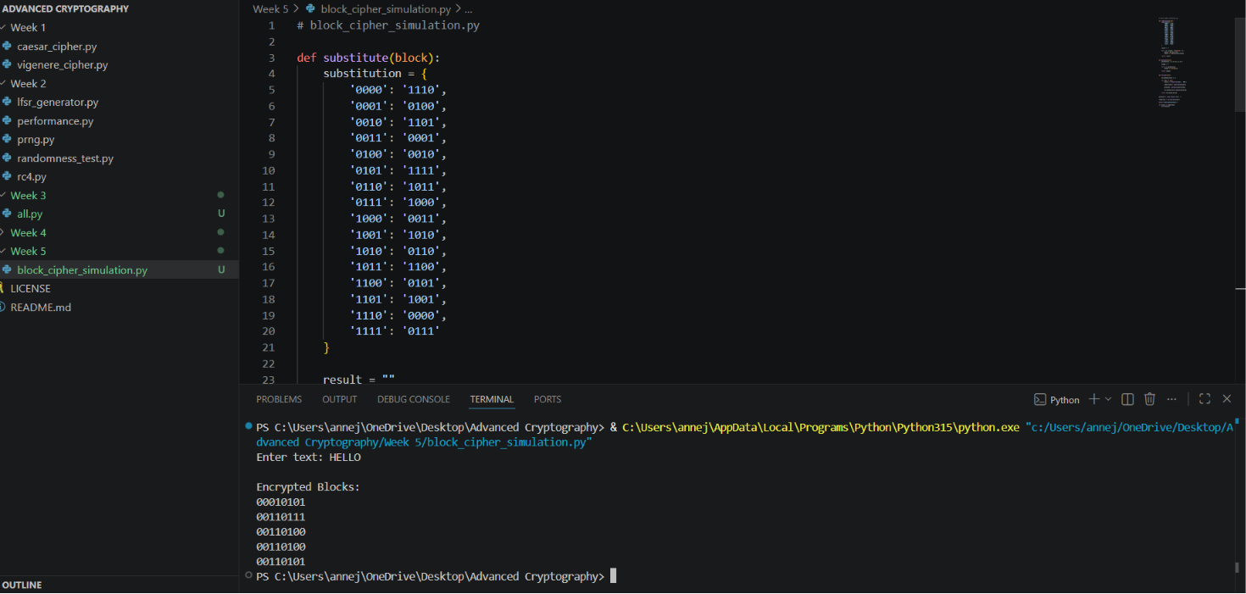

Assignment 1 Explanation

Block Division
Each character is converted into an 8-bit binary block.
Example:
H = 01001000

Substitution
Each 4-bit nibble is replaced using an S-Box lookup table.

Permutation
Bits are rearranged according to a permutation table.

Multiple Block Handling
The program processes every character independently and stores encrypted blocks in a list.

Assignment 2

Mini Research Report on DES, AES, Feistel Structure, Confusion and Diffusion

Introduction
Modern cryptography protects information from unauthorized access. Block ciphers are widely used for securing digital communications. DES and AES are among the most important symmetric encryption algorithms.

Data Encryption Standard (DES)
DES is a symmetric-key block cipher developed by IBM and adopted in 1977.

Features
- 64-bit block size
- 56-bit key size
- 16 Feistel rounds
- Uses substitution and permutation

Advantages
- Simple design
- Efficient in hardware

Disadvantages
- Short key length
- Vulnerable to brute-force attacks

Advanced Encryption Standard (AES)
AES replaced DES in 2001 and is currently the most widely used encryption algorithm.

Features
- 128-bit block size
- Keys of 128, 192, or 256 bits
- SubBytes operation
- ShiftRows operation
- MixColumns operation
- AddRoundKey operation

Advantages
- Highly secure
- Fast execution
- Resistant to known attacks

Disadvantages
- More computationally complex than DES

Feistel Structure
A Feistel structure divides data into two halves and performs multiple rounds.

Process
- Split plaintext into left and right halves.
- Apply round function to the right half.
- XOR result with left half.
- Swap halves.
- Repeat for multiple rounds.

Formula
Li+1 = Ri
Ri+1 = Li XOR F(Ri,Ki)

Benefits
- Same structure for encryption and decryption.
- Efficient implementation.

Confusion
Confusion obscures the relationship between the key and ciphertext.

Methods
- Substitution
- S-Boxes

Purpose
Makes key discovery difficult.

Diffusion
Diffusion spreads the effect of a single bit change across the ciphertext.

Methods
- Permutation
- Bit shuffling

Purpose

Prevents statistical attacks.

Assignment 3
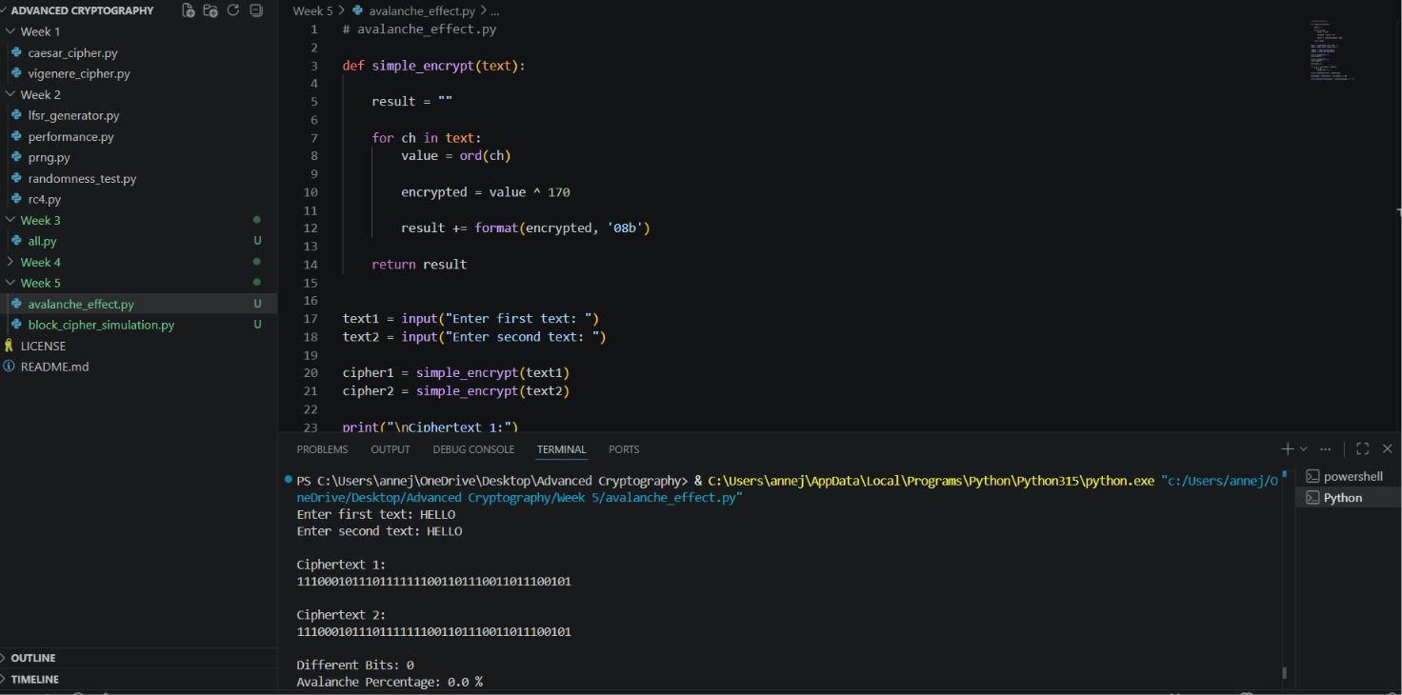
Figure 4shows avalanche performance of HELLO

STUDENT REFLECTION
Through these activities, I learned the basic concepts of block cipher cryptography, including permutation, XOR operations, and the Feistel structure. I understood how permutation helps achieve diffusion by rearranging bits and how XOR is used during encryption rounds. I also learned the difference between confusion and diffusion and their importance in making encrypted data more secure. Overall, the activities improved my understanding of how encryption algorithms protect information.

WEEK 6: Symmetric Ciphers II –

Substitution-Permutation Networks (SPN), S-

Boxes and Non-Linearity
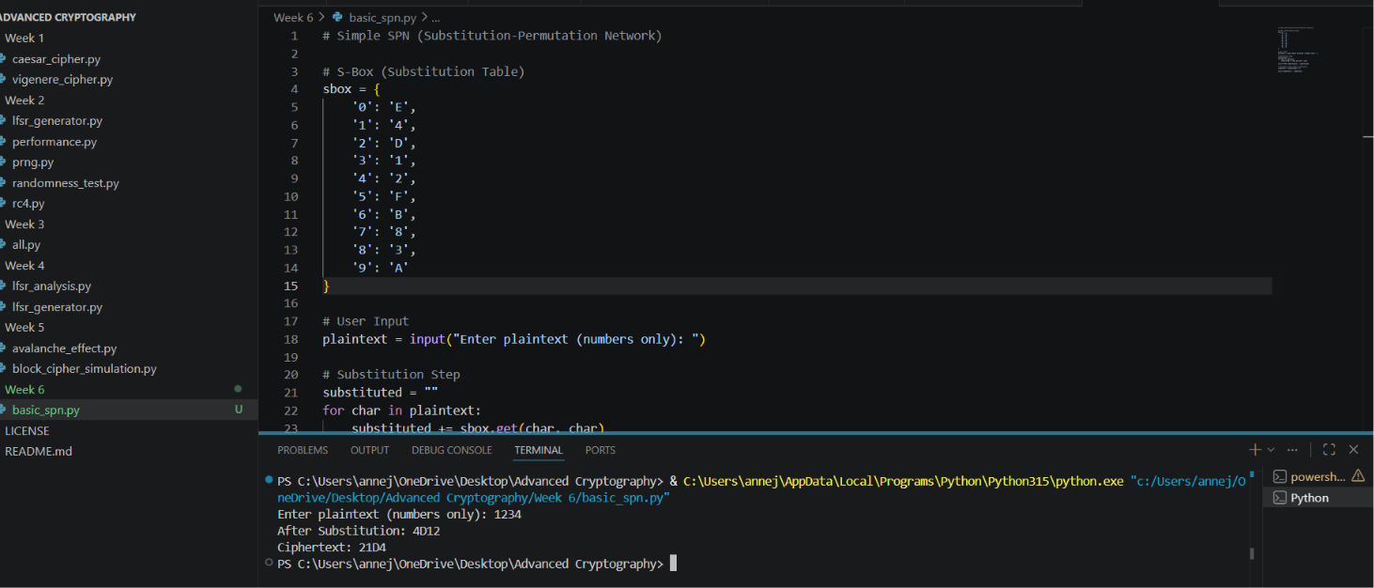
Figure 5Figure X shows the execution of a basic Substitution‑Permutation Network (SPN) on the plaintext 1234. The S‑box defined in the script maps each input digit to a corresponding hexadecimal output:

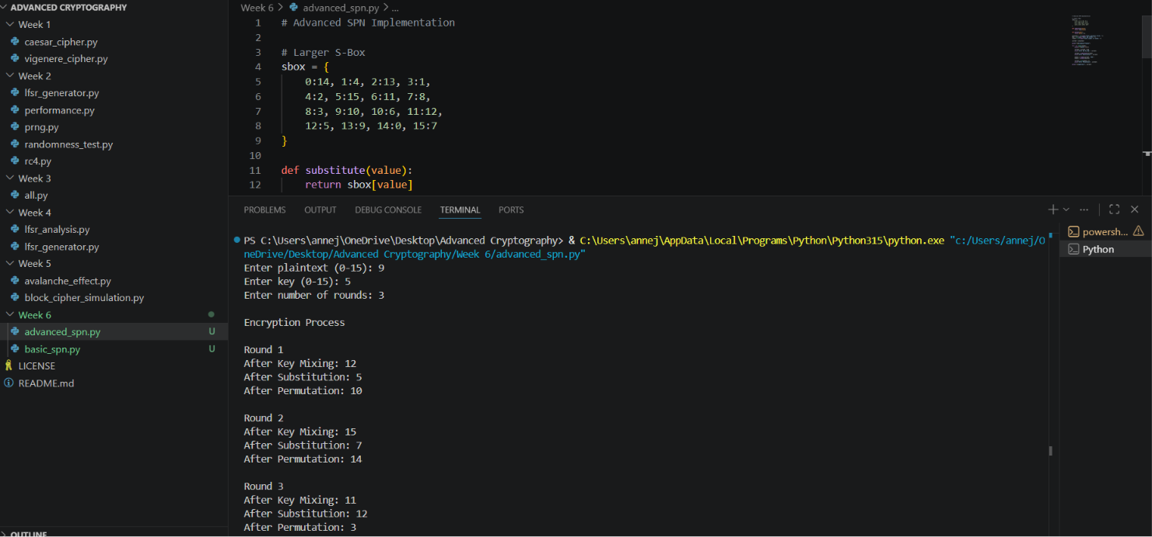
Figure 6This figure shows a 3-round SPN encryption trace. With plaintext 9 and key 5, each round performs key mixing, S-box substitution, and permutation. Round outputs progress as: Round 1 (12→5→10), Round 2 (15→7→14), Round 3 (11→12→3). Final ciphertext is 3.

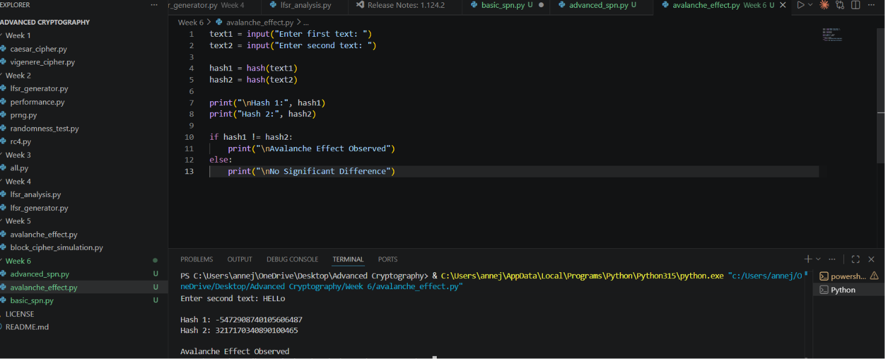
Figure 7This figure shows a mini-AES simulator on 4-bit blocks. Encryption of plaintext 9 with key 5 produces ciphertext 3. Decryption successfully recovers 9, verifying correct SPN implementation with both encryption and decryption.

Week 7: Block Cipher Cryptanalysis –

Algebraic Attacks, Differential Cryptanalysis and Linear Cryptanalysis

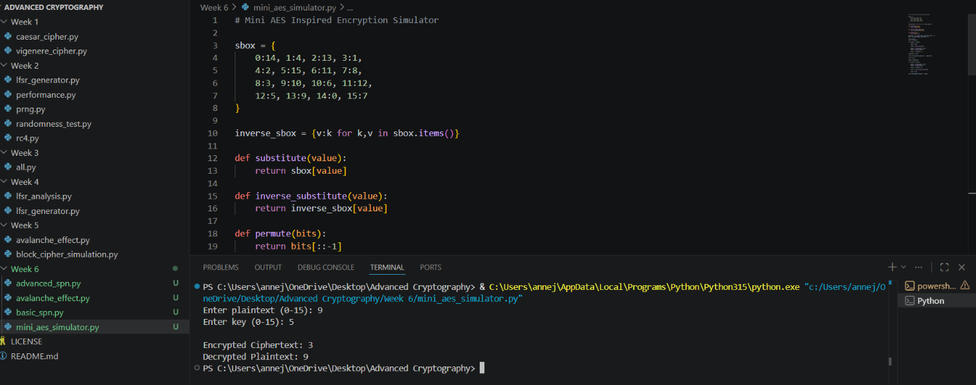
Figure 8This figure shows cryptanalysis results on two identical plaintexts ("HELLO"). Frequency analysis shows H:2, E:2, L:4, O:1. Most common character L appears 4 times (40% bias). A moderate statistical bias is detected.

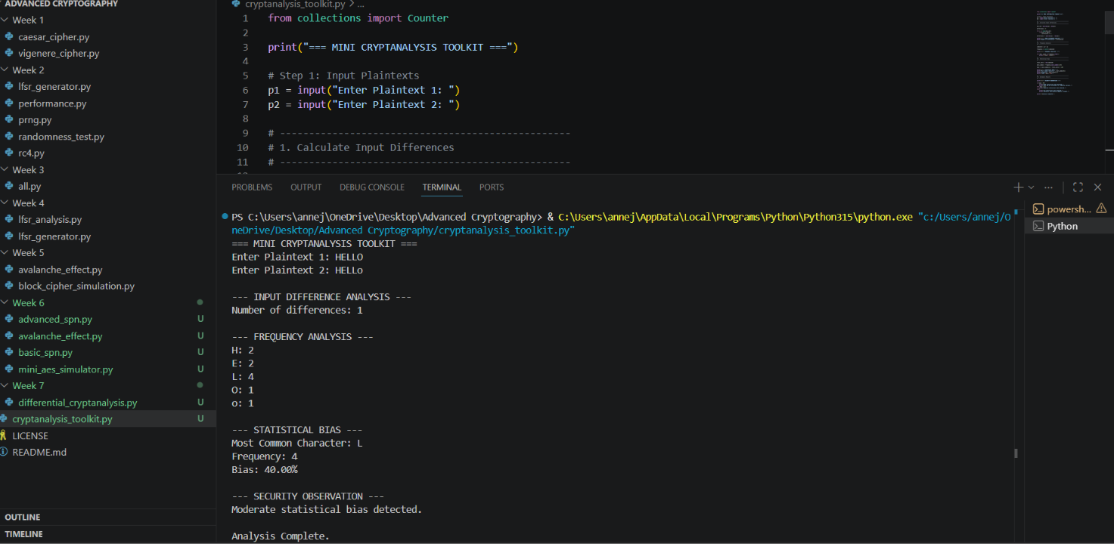
Figure 9This figure shows cryptanalysis on two identical plaintexts "HELLO". Frequency analysis reveals H:2, E:2, L:4, O:1. Character L appears 4 times (40% bias), indicating a moderate statistical bias.

